8-bit MIPS Microprocessor

EE497 Final Report

Jared Hayes

Nick Repetti

Jason Silic

Faculty Advisor: Dr. R. Jacob Baker

4 December 2014

Table of Contents

1. Introduction…………..………………………………………………….………...3

1.1. Introduction………………………………………………………...……...3

2. System Overview…….....………………………………………………….……...3

2.1. Instruction Set.………..…………………….………………...…………...3

2.1.1. Instruction Description…………………………………...………..4

2.1.2. Instruction Fields………………………………………………….5

2.2. System Architecture…………………………………………………….....6

2.3. Functional Analysis and Requirements…………………………………...7

2.4. Trade-offs………………………………………………………………….7

3. SRAM…….………………………………….....………………………………....8

3.1. Design and Implementation……………………………………………….8

3.2. Precharging Circuit………………………………………………………..9

3.3. Write Circuit Design……………………………………………………..10

3.4. Example Simulation……………………………………………………...11

4. Control Unit……………………………………………………………………...12

4.1. Overview…………………………………………………………………….12

4.2. Control Signal List

4.3. Control Signal Block Diagram

5. Register File……………………………………………………………………...12

5.1. Design and Implementation……………………………………………...12

5.2. Alternatives and Trade-Offs……………………………………………..18

6. ALU……………………………………………………………………………...18

6.1. Design and Implementation……………………………………………...18

6.2. Simulations……………………………………………………………....22

7. Test Plan………………………………………………………………………….24

8. Prototype Cost Estimate………………………………………………………….24

8.1. Cost Estimate……………………………………………………………….24

9. User Manual Outline……………………………………………………….…….25

9.1. How to Use………………………………………………………………25

10. Management Plan………………………………………………………………...25

10.1. Team Meetings, Documentation and Communication………………….....25

10.2. Risks and Mitigation Plan……………………………………………...…..25

10.3. Timeline…...……………………………………………………………….26

Appendix A……………………………………………………………………………....27

A.1. Additional Schematics…………………………………………………...27

A.2. Control Signal Generation For All Instructions, simulation of entire chip

1. Introduction

**1.1 Introduction**

MIPS (Microprocessor without Interlocked Pipeline Stages) is a popular implementation of a reduced instruction set computer (RISC). MIPS architectures are typically 32-bit, but 64-bit versions have been developed in more recent years. It became a widely used processor for embedded systems design and has been implemented in many consumer electronics products. These included routers, devices that ran Windows CE, and Sony video game consoles. Due to its popularity in modern electronics in the 1990’s, it has often been studied in computer architecture courses. It is an effective, yet simple processor that fulfills the features required in a modern processor but without too much unnecessary complexity.

We will be designing an 8-bit MIPS processor, which is a significantly reduced version of the typical MIPS processor. Our motivation for this project is to create a simplified version of the processor to be utilized in computer architecture and embedded systems courses. The design of an 8-bit processor more plausibly fits with our educational budget and resources. Since our processor will be much easier to interpret and apply than most modern microprocessors, students can use it to create simple projects as an entry into embedded systems. The process we used in the design of the processor can be used to teach processor design and the fundamentals of computer architecture in the form of educational labs. This project is an extensive and rigorous test of the skills acquired in a computer/electrical engineering degree program, requiring knowledge in computer hardware/architecture, digital electronics design, embedded systems, and an understanding of programming languages.

1. System Overview

**2.1 Instruction Set**

Our processor uses a modified instruction set with 16-bits per instruction, instead of the typical 32-bit instruction set. This system was chosen because our onboard SRAM is only 512 bytes, so conserving memory is very important. Also, the large instruction size is mostly to accommodate large register files (32 registers is typical) and large memory spaces. We only need nine bits to specify a memory location, so even our jump instructions can store the opcode (4 bits), register to compare (3 bits) and absolute address (9 bits) for a total of 16 bits. There was really no need for a larger instruction size which would have just increased the complexity of our design.

The instructions are fetched using two byte-addressable instruction fetches. There are 21 instructions accessed through a 4-bit opcode and 3-bit flag field on arithmetic and IO instructions. For example, opcode 0000 is an arithmetic instruction, with the particular instruction (ADD, SUB, XOR, etc.) determined by the bits in the Flags field.

The encoding for the various instructions is as follows:

**Table 1**

**opcode instruction opcode instruction**

0000 ARITH 1000 JNE

0001 LOAD 1001 JGE

0010 SHL 1010 [not used]

0011 SET 1011 NOP

0100 IO 1100 JE

0101 STORE 1101 JG

0110 SHR 1110 ROR

0111 STOP 1111 STOP*

*Note that the STOP instruction has two opcodes used for it.

The ARITH instruction breaks down as follows, depending on the Flags field

**flags instruction flags instruction**

000 ADDI 100 AND

001 ADD 101 NOT

010 SUB 110 XOR

011 OR 111 [not used]

The IO instructions depend on the least significant bit of the Flags field.

If it is 0, the instruction is IN, otherwise the instruction is OUT.

**2.1.1. Instruction Description**

The basic operation of the instructions is described here. The following section will describe how the various fields in the 16-bit instruction are used.

The instructions are presented below with this format:

r0, r1, r2 are 3-bit fields that specify one of eight registers.

L9 is a nine bit literal used to specify a jump address.

L6 is a six bit literal used for the ADDI instruction.

L8 is an eight bit literal used for setting a register to a value

L3 is a three bit literal to control the amount of shifting or rotation for SHL, SHR, and ROR instructions.

**Table 2: Instruction Description**

ADD r0, r1, r2 - r0 gets the result of r1 + r2

ADDI r0, L6 - r0 gets the result of r0 + L6 (sign extended)

SUB r0, r1, r2 - r0 = r1 - r2

OR r0, r1, r2 - r0 = r1 | r2 //this is a bitwise OR operation

AND r0, r1, r2 - r0 = r1 & r2 //this is a bitwise AND operation

NOT r0, r1 - r0 = ~r1 //this is a bitwise inversion

XOR r0, r1, r2 - r0 = r1 ^ r2 //this is a bitwise XOR operation

IN r0 - r0 get the value placed on the IO input pins

OUT r0 - The value in r0 is placed into the output register, with external output.

JE r0, L9 - Jump to address L9 if r0 is equal to zero.

JNE r0, L9 - Jump to address L9 if r0 is not equal to zero.

JG r0, L9 - Jump to address L9 if r0 is greater than zero [signed comparison]

JGE r0, L9 - Jump to address L9 if r0 is greater than or equal to zero [also signed]

LOAD r0, L9 - Load data at address L9 into register r0

STORE r0, L9 - Store the contents of register r0 at address L9

SET r0, L8 - Store the value L8 into register r0

STOP - Stop the execution of the current program, until a reset signal.

NOP - No operation.

SHL r0, r1, L3 - Shift register r1 left by L3, store result in r0. [Shift in zeros]

SHR r0, r1, L3 - Shift register r1 right by L3, store result in r0. [Shift in zeros]

ROR r0, r1, L3 - Rotate the bits in r1 to the right by L3 positions, store in r0

**2.1.2. Instruction Fields**

The arithmetic instructions use the Arithmetic Instruction Format, with three registers. The ADDI instruction uses two of the register slots for a six-bit immediate value. The jump and load/store memory instructions need a nine-bit address, so they use the third format. The SET instruction also uses this format, but only the lower eight bits are used. The three-bit literal for the shifting instructions is stored in the flags field of the first instruction format.

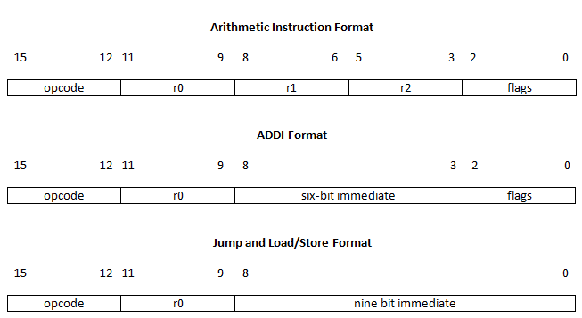

**2.2 System Architecture**

The main components of the MIPS processor include:

· Control Unit

· SRAM

· ALU

· Register File

*Control Unit*

This processor is essentially a massive state machine. Neglecting the SRAM for a moment, the CPU’s state is completely defined by the contents of the register file, ALU registers, and control unit registers. The next state is a deterministic result of the current state, and is achieved by the use of only twenty-four control signals. These control signals are generated by combinational logic which has a delay less than one-half of a clock cycle.

Some of these control signals are for the internal use of the Control Unit (CU). For example, the StepReset signal will reset the step counter, which tracks the current instruction’s stage of execution. Other signals are for the ALU arithmetic logic, such as the three ALU control signals.

The control unit does have some additional responsibilities for the shifting instructions. The barrel shifter in the ALU can only shift data one bit position per clock cycle. To implement longer shifts, a small three-bit counter is necessary.

*SRAM*

The SRAM is of a standard six transistor (6T) design. A simple precharge is applied to the bitlines when the clock signal is high to prevent a low voltage bitline from flipping the datum stored in a cell. Loading data into the SRAM is accomplished by a specialized circuit that aids in the sequential writing of data to the SRAM.

*Arithmetic Logic Unit (ALU)*

The Arithmetic Logic Unit is responsible for all of the Arithmetic and Logic functions that most of the operations rely on. The ALU can perform multiple operations which will be discussed in a later section. Data is clocked into Registers A and B from their respective buses and the appropriate action is performed based on the input signals from the Control Unit. The ALU also handles the calculations for the jump instructions.

*Register File (RF)*

The register file is responsible for storing data in registers specified by the instruction register for use by the ALU. Since this is an 8-bit processor it reads in 3-bit opcodes and decodes them into the clocks of each register. This register file can read two registers and write to a single register at once. Two 3-to-8 decoders help to drive multiplexing for each of the two buses leading out of it. The bus A decoder is also responsible for gating the clock of the registers to select which register to write to. Instead of using multiplexers to determine which registers to output to the buses, 8-bit transmission gates powered by the decoders are used for each register. There are two sets of the 8-bit transmission gates in total, one for each bus.

We present a top-level schematic with the various parts of the processor labeled on the next page. Note the precharge circuit used to always define the voltage on BusA. This is important because when all the tri-state buffers are in the Hi-Z state, the voltage on the bus could float, possibly leading to contention current in inverters connected to the bus. This could lead to failure of the chip, or fluctuations in the power supply voltage.

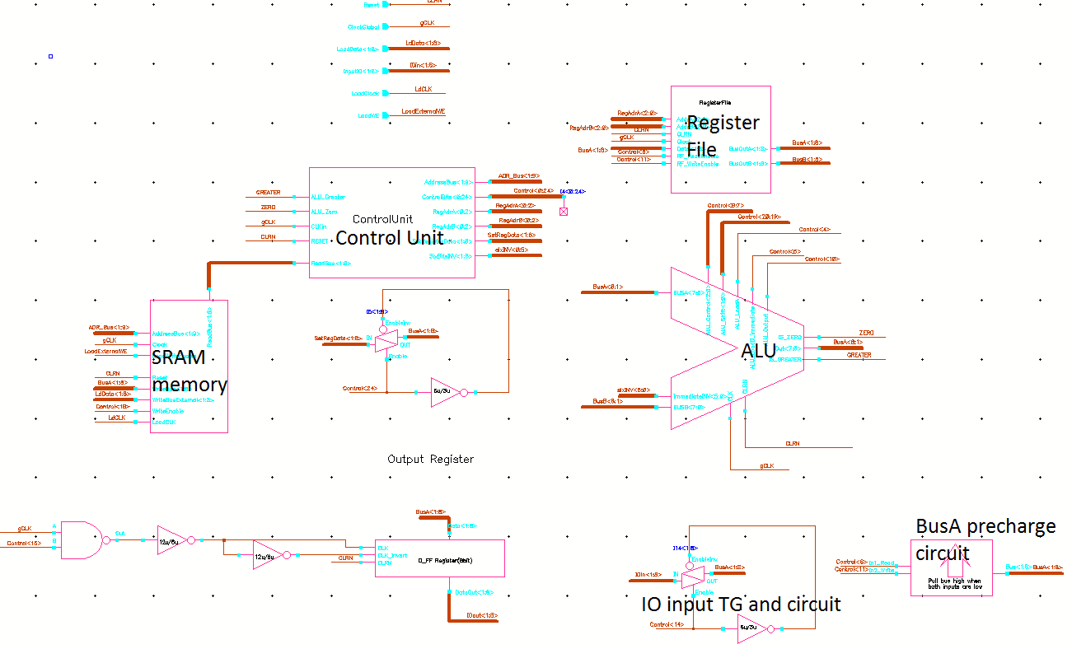

**2.3 Functional Analysis and Requirements**

Our processor is designed and simulated using Cadence Virtuoso design software with Spectre and Ultrasim simulation plugins. The processor must be designed from scratch on the transistor level and fabricated on a chip using the MOSIS On Semiconductor 500 nm rules and the C5 CMOS process, which contains 2 polysilicon layers and 3 metal layers. Therefore, all digital logic and components will be custom made in order to fit the specifications of our project and the MOSIS design rules. Cadence allows us to design the chip layout according to those rules and will make checks to ensure that our layout stays consistent with them. The fabrication process takes considerable time and resources; therefore, we must ensure that our design is properly simulated so that our fabricated chip works as intended in our design. We use Spectre and Ultrasim to simulate the schematics of all of our components to ensure proper operation. Then, Cadence checks that our layouts exactly match the schematics in order to adhere to our simulation results.

**2.4 Trade-offs**

We had to consider many trade-offs in order to simplify our processor to fit our time constraints and resources. Designing an 8-bit processor instead of a 32-bit processor obviously reduces the chip’s processing power and capabilities. Using a 16-bit instruction set allows the user to have a simpler and more streamlined set of instructions, but at the cost of flexibility. We also chose to forego implementing a pipelined microarchitecture. A pipelined architecture would have improved our processor’s execution time enormously; however, the added design complexity would not have been feasible to implement in our project, considering our time limitations. So, we implemented a multi-cycle architecture instead.

We chose to include on-board memory in our processor, so as to eliminate the reliance of additional off-chip components. Another trade-off we had to consider was the design of the Full Adder. We chose to implement an AOI Adder instead of a Carry Look-ahead Adder because we needed to save space on the chip, but it came at the cost of speed.

1. SRAM

**3.1 SRAM Design and implementation**

The basic SRAM cell stores one bit of information. Our design is the quite common 6T (six transistors) cell. Although a four transistor cell exists, the resistors it used are difficult to fabricate in a small space and contribute to static power dissipation. The basic schematic is presented below, consisting of two cross-coupled inverters and two NMOS access transistors.

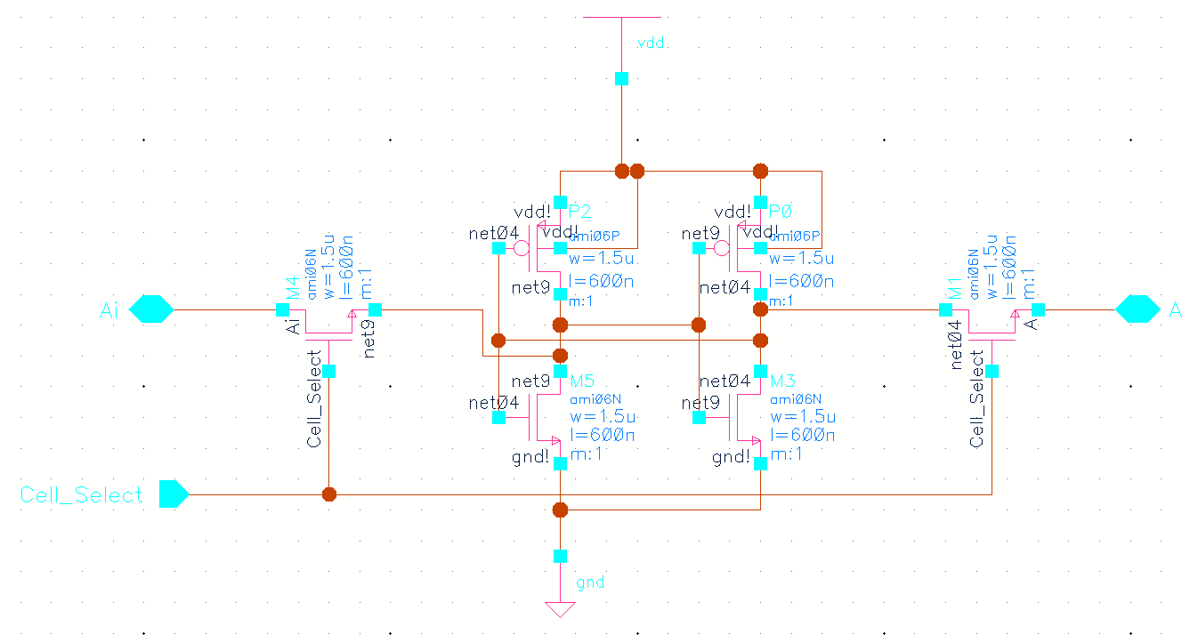

Writing data to the cell is accomplished by overpowering the internal transistors to “flip the bit.” Only writing a low voltage (actually 0V) will work, because the NMOS pass gate passes a logic ‘0’ better and the PMOS transistor is easier to overpower. Therefore, a low voltage on the “A” bitline writes a zero to the cell, and a low voltage on the “Ai” bitline writes a logic one into the cell.

Below is the layout of the SRAM cell, with prominent features illustrated. The bitlines run vertically on Metal3, while the row select and byte select signals run horizontally on Metal2.

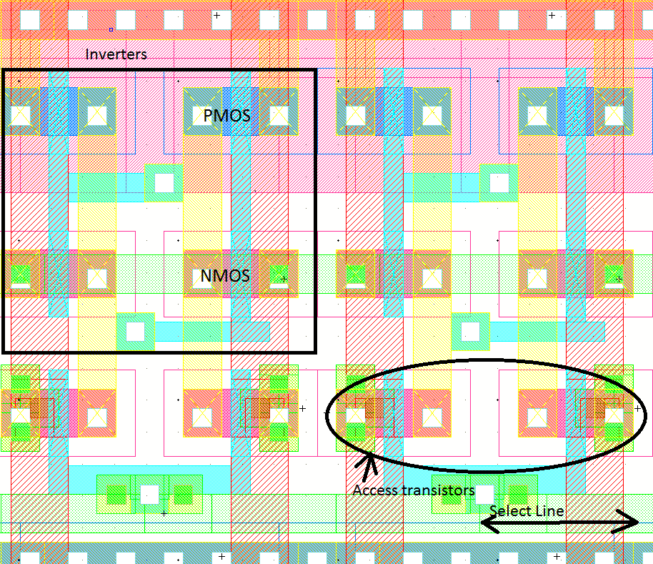

**3.2 Precharging circuit**

The original plan did not include provision for precharging the bitlines. While this would have simplified the design, simulations revealed that a bitline at ground potential could actually write data into another cell when the select line for that cell was asserted. The solution involves “precharging” the bitlines to a high enough voltage to avoid this problem. Although charging the bitlines to VDD- Vthn through an NMOS transistor could have worked, I decided to do a more complicated three-transistor design to get a more precise voltage. The stable output voltage of the below circuit is about 3.24V, with a 10MEG load to ground. The long length transistors limit the current that can flow, making sure the maximum sustained current is less than 100uA/via.

When the input is low, the PMOS transistors turn on and move the voltage on the output line toward 3.2V.

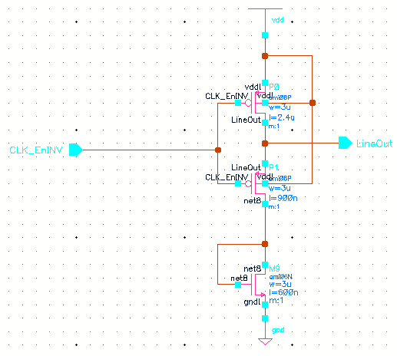

**3.3 Write Driver circuit**

When data is loaded into the SRAM, the data comes from an external source. In addition, data is loaded into sequential memory locations, starting at 0x000. Therefore, the address bus is connected to a nine-bit upcounter, and the write bus is connected to the external input. The external procedure for writing data to the SRAM is simple. Assert the Load Write Enable signal, and send a reset signal (Reset is active low) to reset the address counter. The values on the 8 input lines will be written to the SRAM on active clock edges. Additional schematics can be found in Appendix A.

The write circuit may also be of interest in this design. In the below schematic, powerful 6 micron wide NMOS transistors are strong enough to write data into the SRAM cells. The logic for writing is simple enough. A high signal at the gate of the NMOS will write a zero into the 6T cell. Therefore, the write signals need to be inverted first, a task accomplished by the NOR gate. When the enablei signal is low, the NOR gate is an inverter, and correct data is written into the SRAM. When the enablei signal is high, the output of the NOR gate is low, and the transistors are off. This allows read operations to proceed.

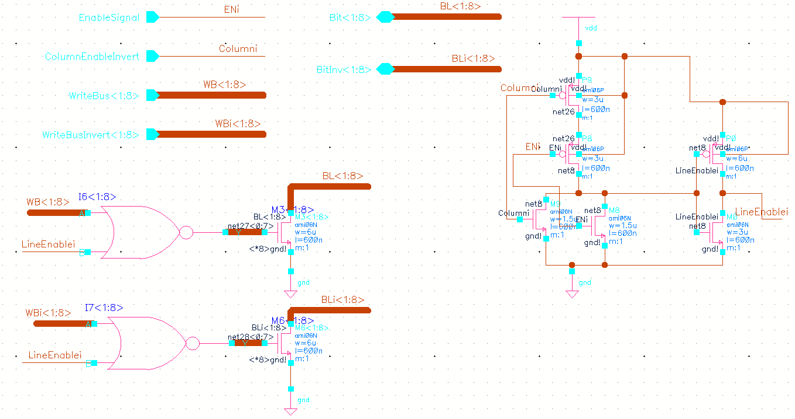

**3.4 Example Simulation**

The following simulation shows some data being loaded into the SRAM and then a read operation. Note in section 1 that the number written is 0010000, and the same number is read in section 2. (Admittedly, the diagram is difficult to read.)

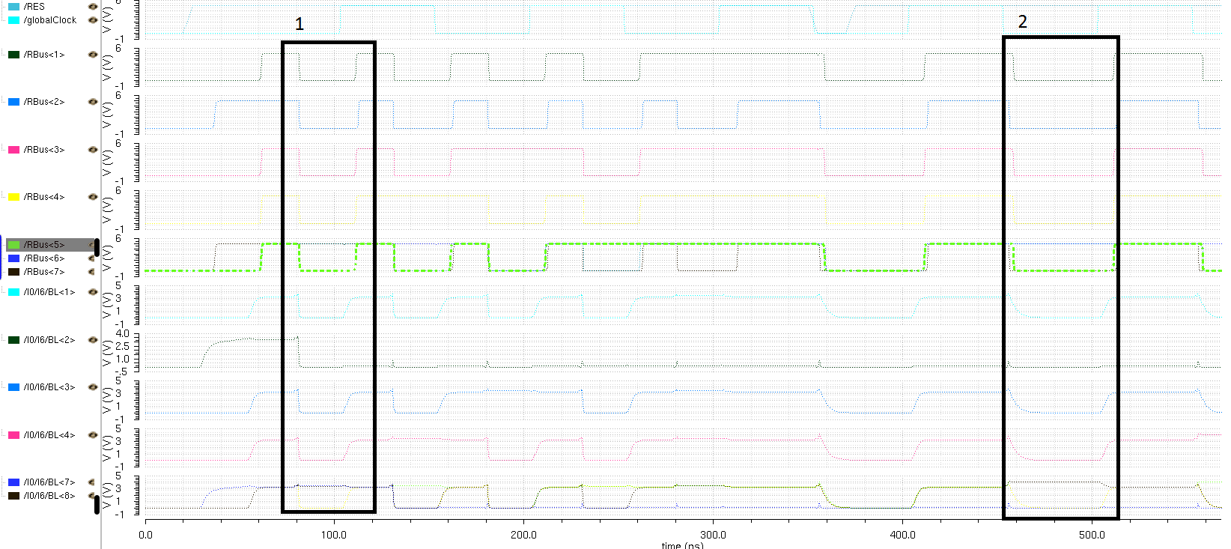

1. Control Unit

**4.1 Overview**

The control unit is probably the most complex part of the processor. It includes the instruction register (IR), a 3-bit downcounter for the shift instructions, a step counter to track the current stage of the instruction, and a large block of combinational logic to generate control signals for the entire CPU. The Control Unit (CU) controls not only the ALU but also the SRAM (read and write signals) and the internal state of the CU (when to reset the step counter, for example).

The first stage of the control unit determines the current instruction by decoding the 4-bit opcode and any relevant flags. The main stage of combinational logic determines appropriate control signals to generate based on the current instruction opcode, the value of the step counter, and whether the shift counter has reached zero for the shifting instructions.

**4.2 Control Signal List**

The following list describes the twenty-five control signals, and their purpose:

Number Name Purpose

0 - PC_Update - Load a new value into the program counter

1 - PC_LoadImmediate Load data from IR into PC (for jump instructions)

2 - IR_ReadLow Load lower byte of IR from memory

3 - IR_ReadHigh Load upper byte of IR from memory

4 - ALU_LoadA Load ALU registers

5 - ALU_LoadBImmediate Load value from IR (used for ADDI instruction)

6 - RF_ReadEnable Read data from RF to BusA and BusB

7 - ALU_Control[0] one of three ALU arithmetic control signals

8 - ALU_Control[1] one of three ALU arithmetic control signals

9 - ALU_Control[2] one of three ALU arithmetic control signals

10 - ALU_Output Place ALU register A on BusA for write to RF

11 - RF_WriteEnable Write data on BusA to RF (specified by address A to the RF)

12 - RegisterA_Select Determine which field in IR is used for RF adr. A

13 - StepReset Reset the step counter to begin the next instruction cycle

14 - Input_BusA Read data to BusA from external input pins

15 - Output_BusA Place data on BusA to output register for external IO

16 - Addr_Select Get address for SRAM from IR instead of PC (for load and store instructions)

17 - ReadMem_Enable Read memory contents onto BusA (for LOAD instruction)

18 - WriteMem_Enable Write memory from BusA (for STORE instruction)

19 - ALU_Shift[0] Control signal for ALU barrel shifter

20 - ALU_Shift[1] Control signal for ALU barrel shifter

21 - Pause_Step Pause the step counter for the shifting instruction (these instruction take a variable amount of time to complete, depending on the number of times the shift is performed)

22 - GateClock Stop the chip for the STOP instruction (prevent further action)

23 - ALU_LoadCounter Load the Shift counter from the Flags field of the IR

24 - RF_WriteImmediate Write to the RF from the immediate value in IR, not BusA (used for SET instruction)

**4.3. Control Signal Block Diagram**

The following diagram contains a visual block diagram that describes many of the control signals. Some parts, such as the IO circuitry, are missing.

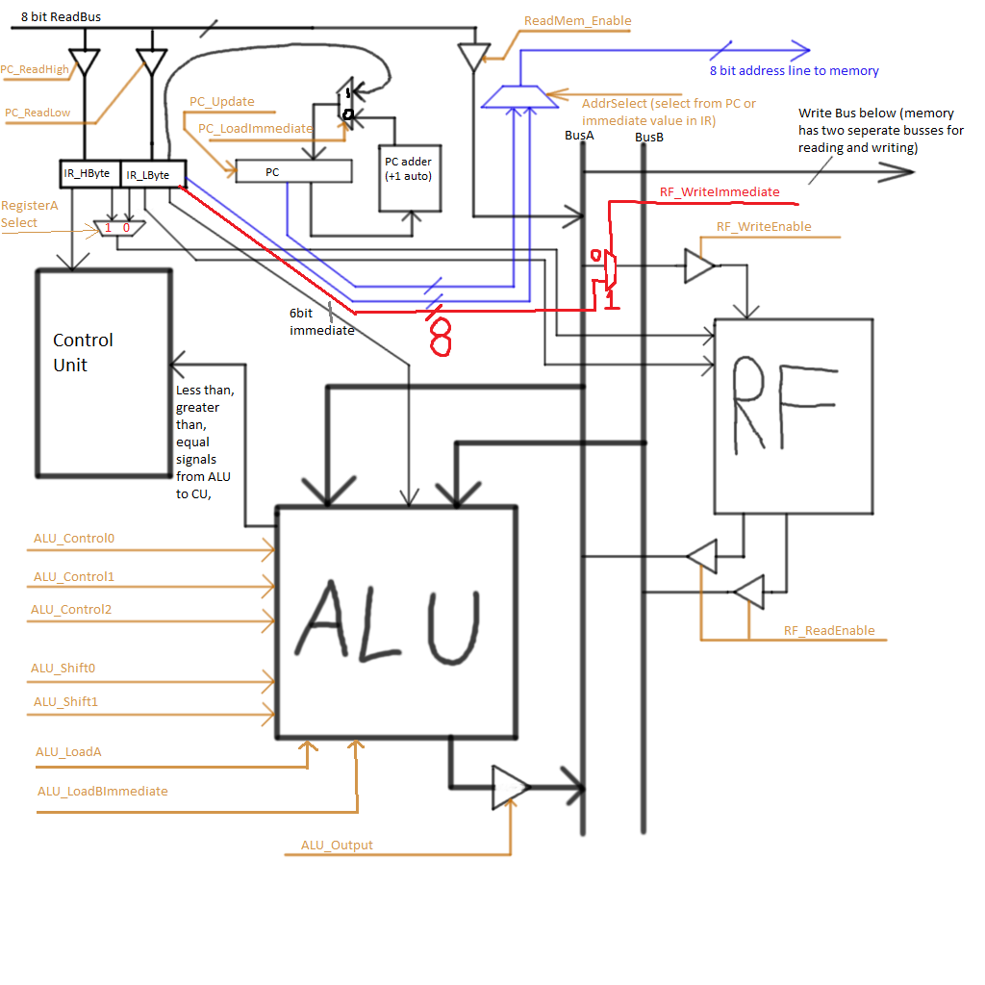

1. Register File

**5.1 Design and Implementation**

Registers

Eight registers composed of 8 D flip flops each, which are in turn composed of 18 transistors each. The majority of the transistors in the register file are of size 6 microns for each PMOS and 3 microns for each NMOS.

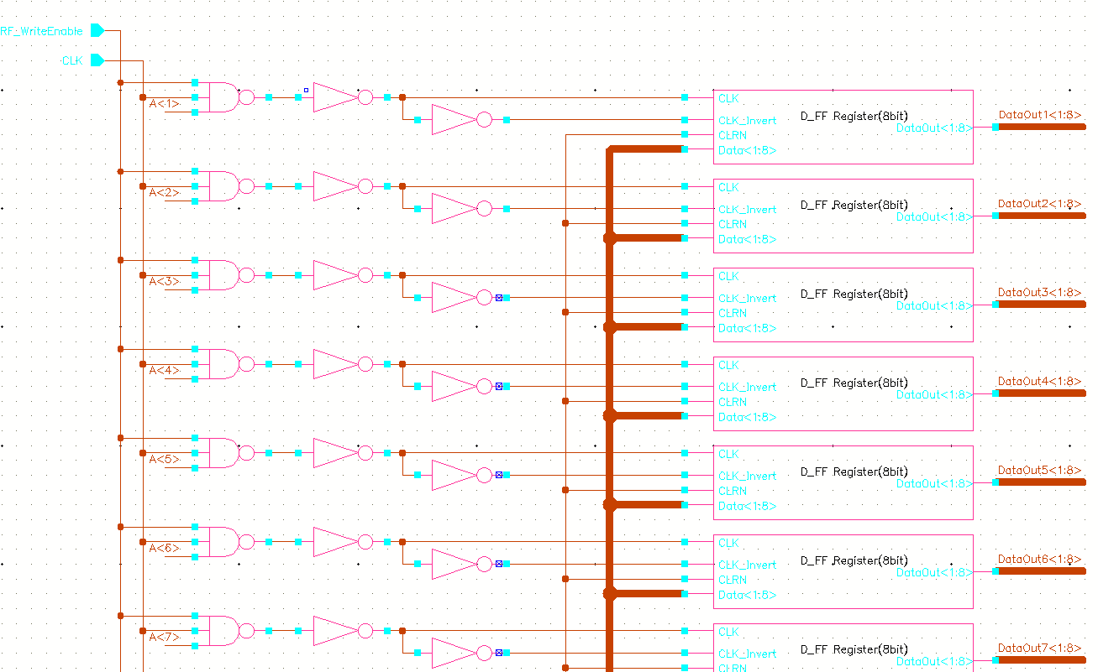

3-to-8 Decoders

There are two decoders, one for address A and another for address B. The outputs of each get sent through an inverter in order to send complimentary signals to the inverted transmission gate enables. The address A decoder is also responsible for gating the clocks of each register to enable writing to that register, as only the registers specified by address A will be written to.

Below is the layout of the first two outputs of the decoder. The bitlines run vertically on metal 3 and the input lines run horizontally on metal 2.

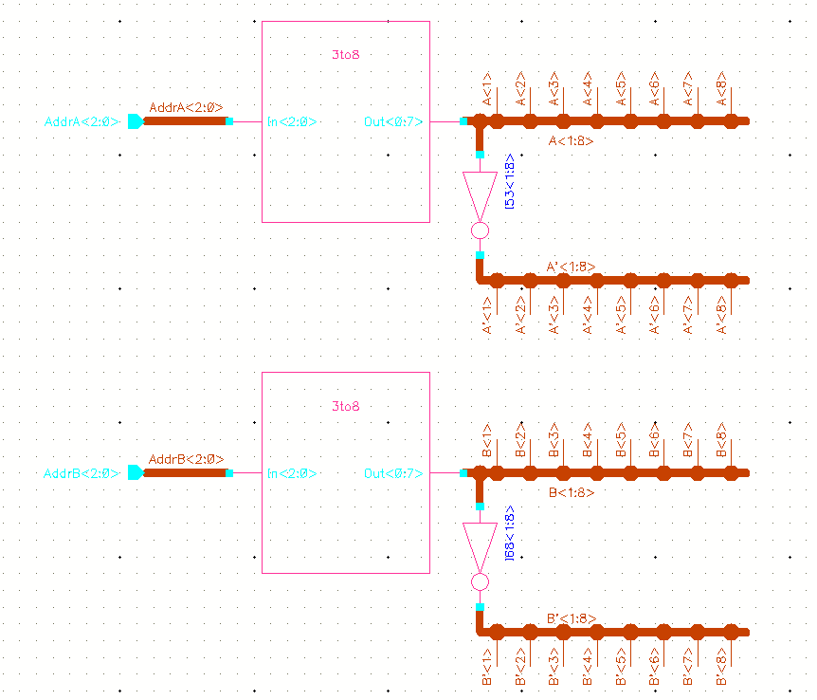

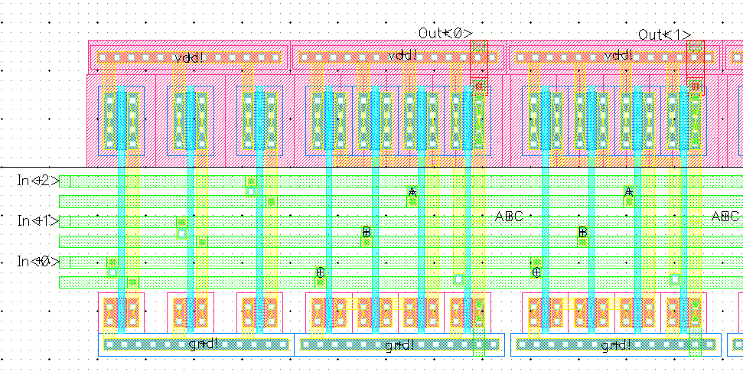

Clock Gating Logic

Gets sent into the CLK and CLK_Invert pins of a register to enable writing.

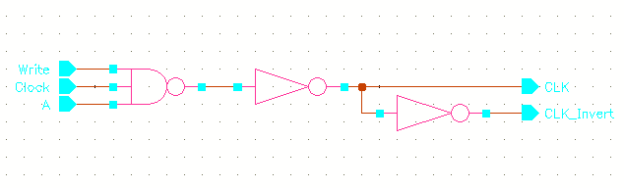

Transmission Gates & Output Buffers

The data from each register is sent into an 8-bit transmission gate (one 1-bit transmission gate for each D Flip-Flop in a register) and then out through an output buffer onto one of the address buses. The decoder outputs are sent into the transmission gate enables to decide which register’s data gets sent to the address bus.

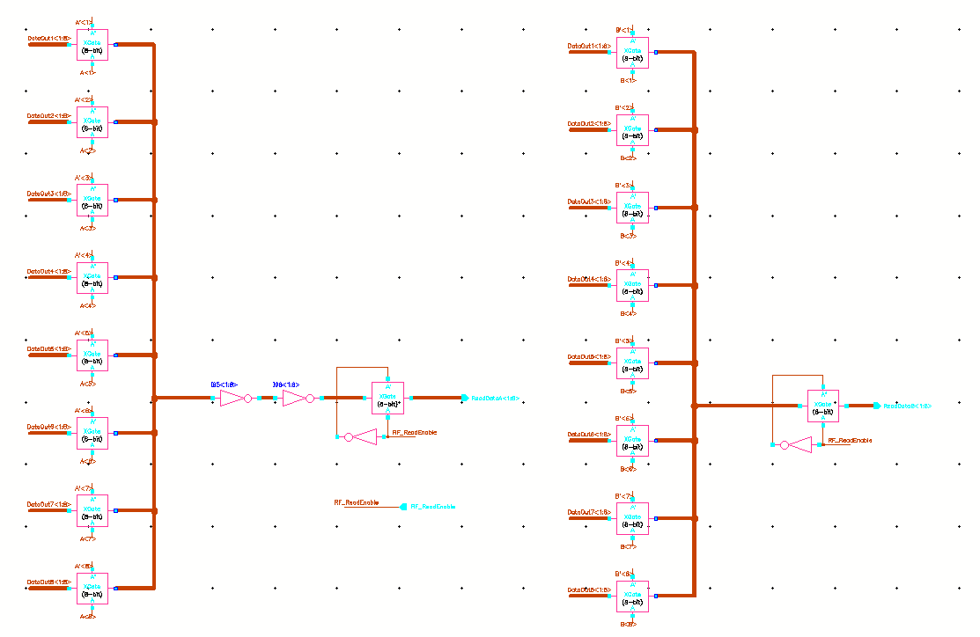

Output Buffer

6-by-3 micron inverters followed by 12-by-6 micron inverters are used to drive the output bus. The transmission gate is turned on to read from the bus by RF_ReadEnable sent by the control unit.

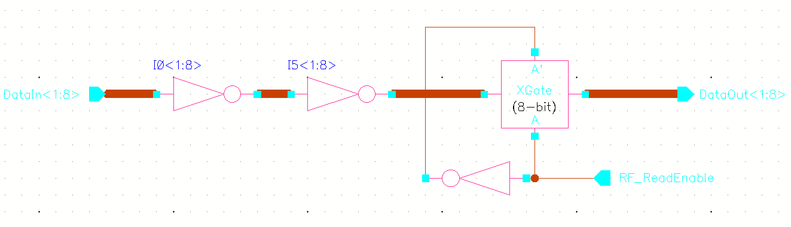

Single Transmission Gate

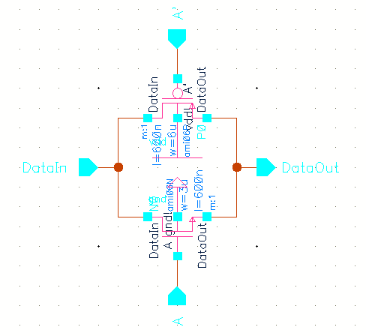

Single Register File Cell

The signals Write_Enable, CLK, and individual outputs of decoder A gate the clock into the register. DataOut<1:8> gets sent to the 8-bit transmission gates, which are enabled by inputs A and B from the decoders.

The layout of the first two bits of the register cell is below. The bitlines and control signals run vertically through the cell on metal 3 and transmission gate enables run horizontally on metal 2.

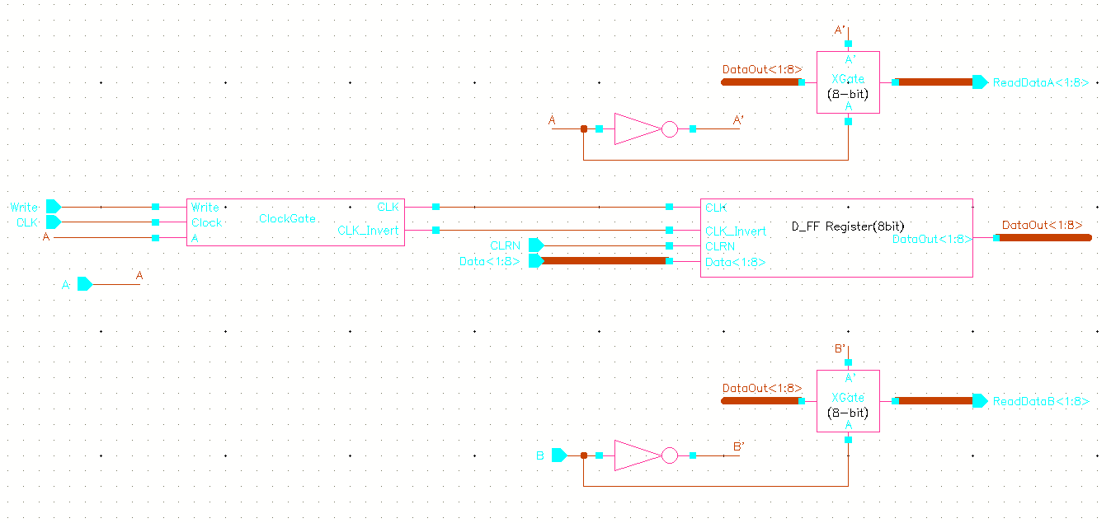

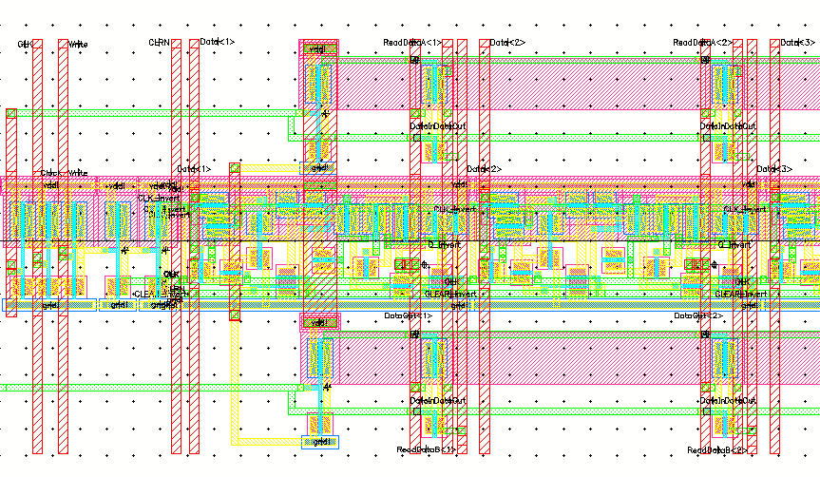

Single Register

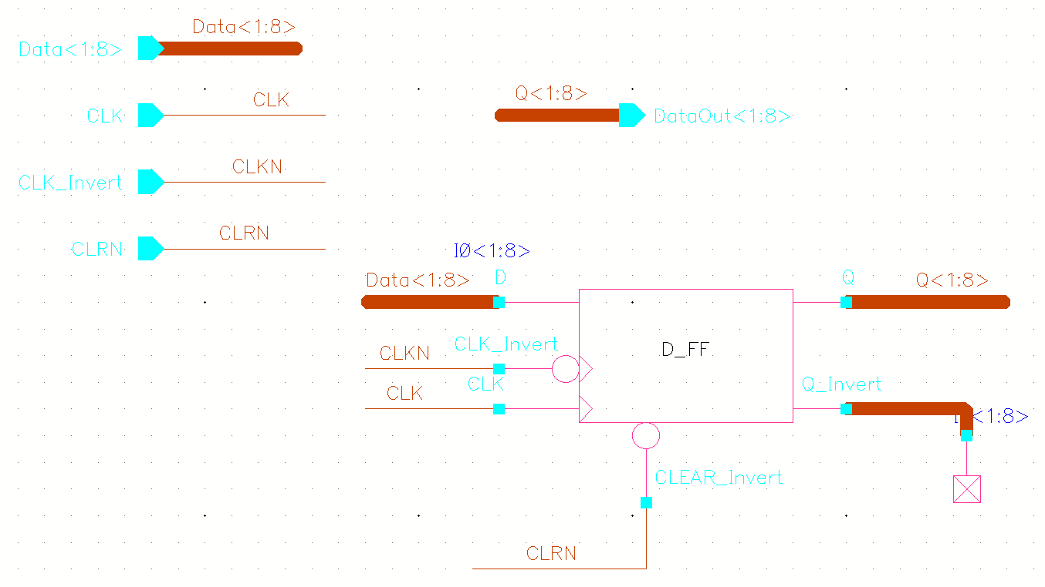

**5.2 Alternatives and Trade-Offs**

A register file is usually implemented with multiplexers. In this case, two 8 to 1 multiplexers would have been used to choose which register’s data would be output onto the buses. However, by replacing the multiplexers with eight 8-bit transmission gates for each bus, we were able to save 256 transistors and the data only has to go through one level of logic instead of three.

1. ALU

**6.1 Design and Implementation**

The major design choice for the ALU was to decide which operations we wanted it to perform. We decided that we wanted to include a Barrel Shifter in the design, which called for two types of control signals. There are five control signals which are comprised of three bits for ALU_Control and two bits for ALU_Shift. The operations that the ALU can perform include the following:

ALU_Control:

000 - AND 100 - Pass Register A

001 - OR 101 - NOT

010 - ADD 110 - XOR

011 - SUBTRACT

ALU_Shift:

00 - Pass Data

01 - Shift Left

10 - Shift Right

11 - Rotate Right

The ALU is also responsible for generating the signals for the jump instructions. It can return a true or false value for whether the value in Register A is zero, or whether it is greater than zero. Other components of the ALU include standard logic gates for AND, OR, NOT, and XOR.

The largest component of the ALU is the Full Adder. We designed an And-Or-Invert (AOI) Adder in order to save layout space. A Carry Look-ahead Adder was our first choice because it performed the operations with a minimum amount of clock cycles, but it required too large of a space to fit on our chip. The Adder has input and output signals for Input A, Input B, Carry In, Carry Out, and Sum. Each Carry In bit is generated from the previous bit’s Carry Out, except for bit 0. For addition, the first bit’s Carry In is 0, so the first sum is A + B + 0. Subtraction is achieved through binary two’s complement where A - B = A + B**’** + 1. To accomplish this with our adder, the B bit is inverted, and then the first bit’s Carry In is 1.

The final component of the ALU is the Barrel Shifter. Each bit is designed with a 4-1 Multiplexer which feeds in a value based on the operation to be performed. If it is a left shift, then the previous bit’s value is shifted into the current bit. If it is a right shift, then the next bit’s value is shifted into the current bit.

Overall ALU Schematic (Broken into 3 images)

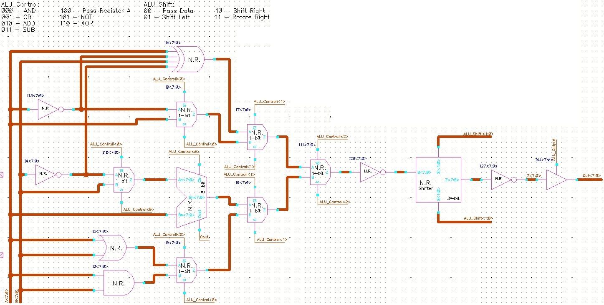

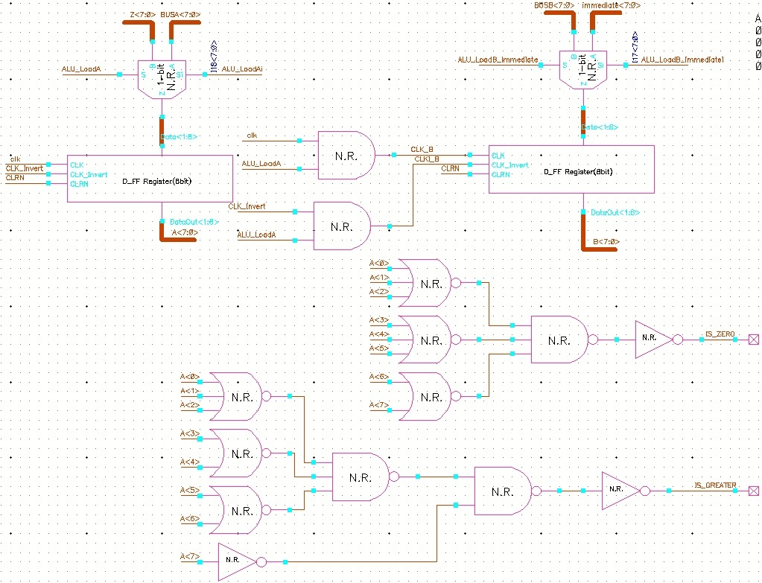

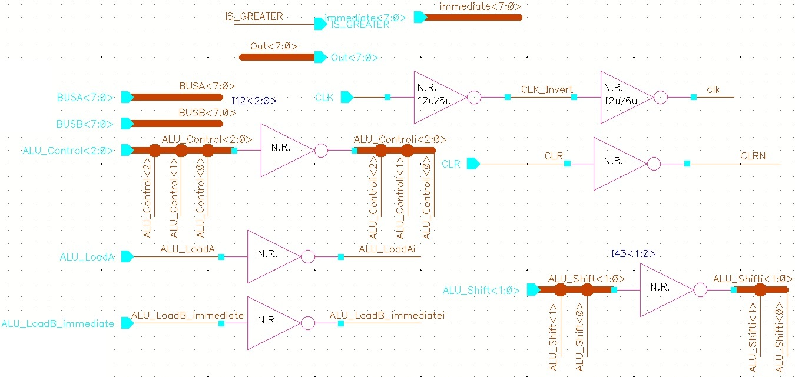

1-bit Full Adder Schematic

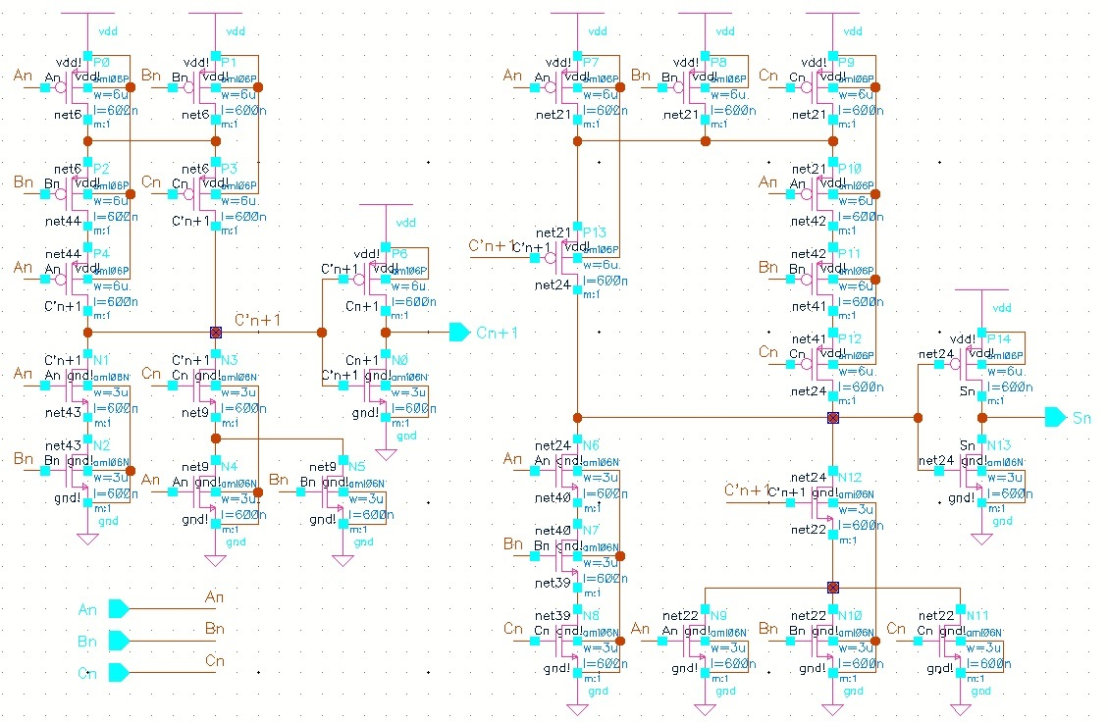

Barrel Shifter Schematic

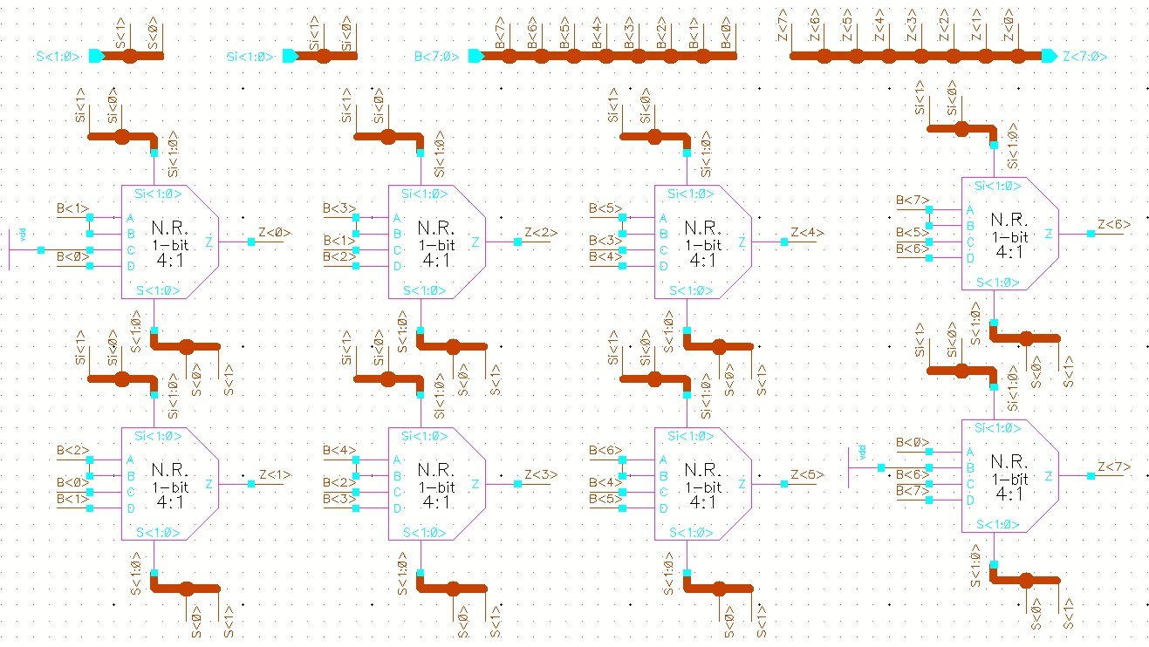

**6.2 Simulations**

The next section will cover a few simulations demonstrating the operation of the ALU.

ADD Simulation

The following is a simulation for four addition operations, each occurring every 100 ns.

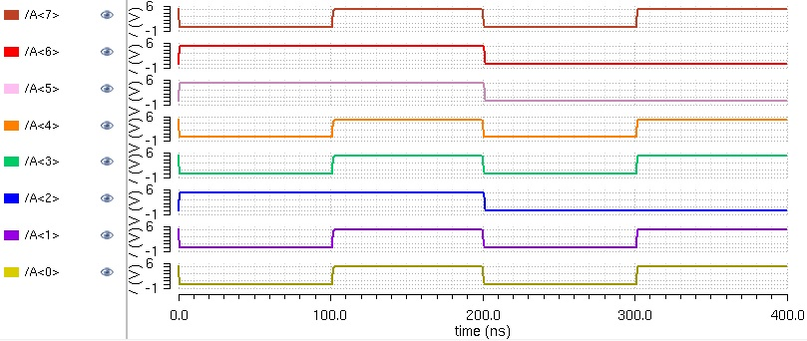

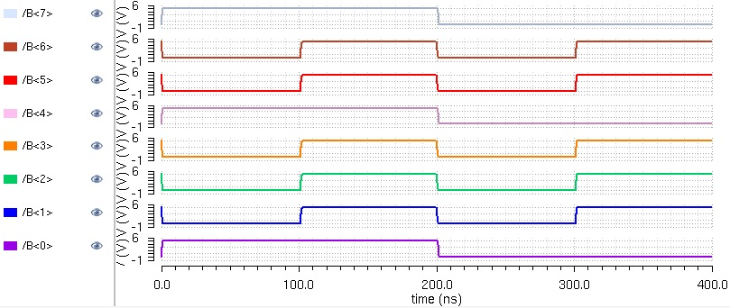

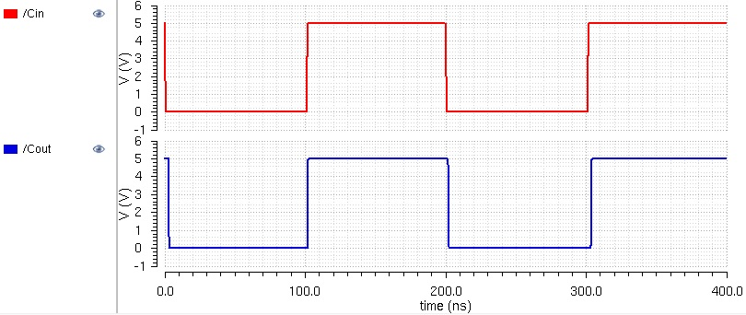

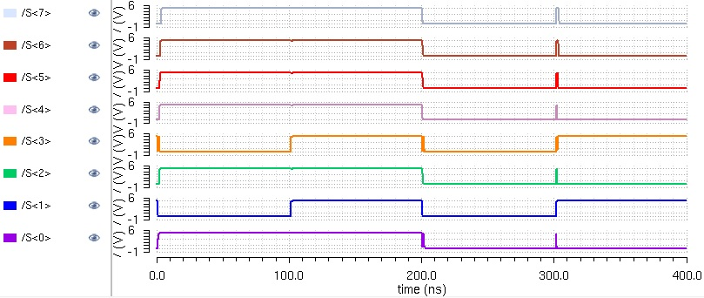

A few analyses of the simulations are as follows:

**Time: 0-100 ns**

A = 01100100 = 100 (in decimal)

B = 10010001 = 145 (in decimal)

Cin = 0

S = 11110101 = **245** (in decimal)

Cout = 0

**Time: 300-400 ns**

A = 10011011 = 155 (in decimal)

B = 01101110 = 110 (in decimal)

Cin = 1

S = 00001010

Cout = 1

Since we have Cout = 1, we bring the 1 in front of the S, giving us a value of

Sum = 100001010 = **266** (in decimal)

AND Simulation

Using the same values for A and B, we simulate the AND operation and the results are below:

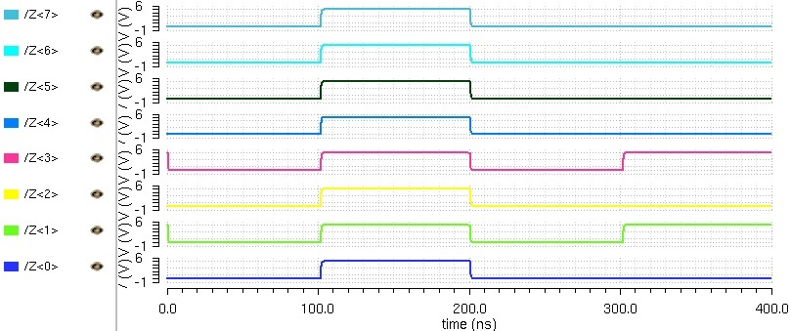

**Time: 300-400 ns**

A = 10011011

B = 01101110

Z = **00001010**

It can be seen that the ADD function works properly.

1. Test Plan

In order to test the chip, we plan to develop a PCB board with our MIPS chip mounted on the board. We will also use a microcontroller to help with the clock generation and program loading. The processor will be connected to LEDs in order to verify outputs and results. We will run small sets of sample instructions for the processor to run for testing.

1. Prototype Cost Estimate

**8.1 Cost Estimate**

Commercial and personal microchip fabrication prices can cost a very large amount of money. We will be fabricating our microchip through MOSIS. Since we are doing an educational project, MOSIS will be fabricating the chip completely for free. The only cost on our part will be to fill out a survey response commenting on the quality of the operation of the chip in order to help MOSIS perfect their products.

Other costs incurred for the project will be the price of a PCB board, which will depend on the size of the board, and the price of the microcontroller that we will be using to test our chip.

If this were a commercial project, we can make an estimate of how much this prototype would cost. Using round numbers, our team spent about 200 hours designing this chip. At a wage of $30/hour, this is a cost of $6,000. Dr. Baker mentioned a commercial cost of $6,500 for 40 chips, without packaging. Additional costs for the Testing, such as the PCB board can be estimated as $500. In very round numbers we therefore estimate a commercial cost for this prototype in the range from $13,000 to $15,000, assuming no serious additional costs are incurred.

1. User’s Manual Outline

**9.1 How to Use**

In order to use the chip, one must first understand the instruction set. They must then develop a program to be loaded into the SRAM. The program must be written with instructions at the lowest level, in binary, as there is not a compiler for our instructions. From there, they will connect a microcontroller to the chip, and load the program into the SRAM. Next, they must connect the proper output pins from the chip onto LEDs or some form of display. Finally they can run the program on the chip and the output will be displayed onto the LEDs.

1. Management Plan

**10.1 Team Meetings, Documentation and Communication**

The design team has been meeting twice a week on average to discuss design plans. Two months into the project we have reduced the frequency of our meetups to once a week. At least one member of the team meets with our faculty advisor once a week to provide updates on the project and seek advice. We have been using Google Drive in order to communicate outside of meetups and share individual designs.

The first month was spent designing the datapath and the instruction set. The second month was designing and simulating ALU, SRAM, and register file in Cadence. The third month was devoted to designing the control unit and laying out the aforementioned components. By the beginning of the fourth month (December 1, 2014) we planned to have our design ready for fabrication. We fell slightly behind schedule and won’t have a full design ready to submit until the week of December 8, 2014. The time between semesters will be spent designing a PCB to test our chip. We plan to spend the majority of the second semester testing the chip and planning our presentation.

**10.2 Risks and Mitigation Plan**

The first submission run for MOSIS fabrication is the beginning of December. We planned to have our design submitted for that run. In the event that we miss the deadline, we can still submit our design for the second submission run at the end of January. Regardless, we can use the two months between submission dates to optimize our design and prepare a second submission.

Each of the major components are laid out in cells, so that repeated instances of a particular cell will be updated when that cell is revised. This allows for quick revisions in the event that testing results come up negative.

**10.3 Timeline**

Week 3: Project proposal submitted

Week 4: Hand-drawn design and group discussion of instruction set and datapath

Week 5: Rough schematics division of major components design

Components and Skills Required Report submitted

Week 6: Designing of major components and familiarization of Cadence Virtuoso

Week 7: Individual schematic design of major components in Cadence commenced

Week 8: Progress report submitted

Weeks 9&10: Continuation of schematic design in Cadence

Week 11: Layout of major components commenced

Week 12: Design of control unit commenced

1st group meeting with instructor

Week 13: Continuation of schematic and layout design in Cadence

Rough draft of final report

Week 14: 2nd group meeting with instructor

Week 15: Finalization of layout design of major components

Week 16: Submit Final Report, Finalize design of the entire chip for submission

Week 17: Submit chip for fabrication and presentation

Appendix A

**A.1 Additional Schematics**

2-1 Multiplexer

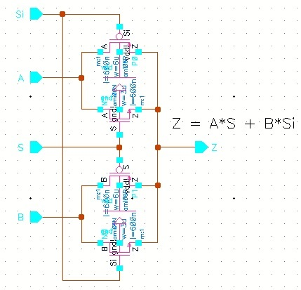

4-1 Multiplexer

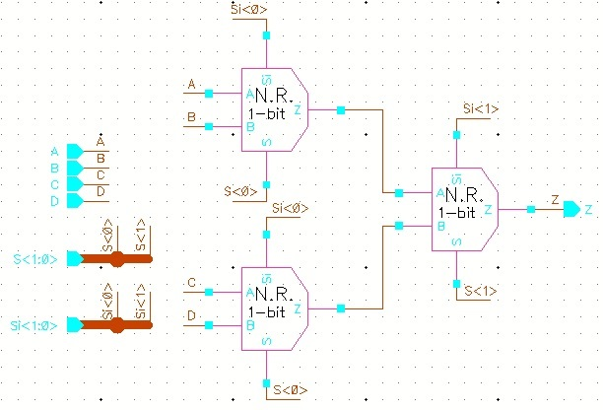

6/3 Inverter

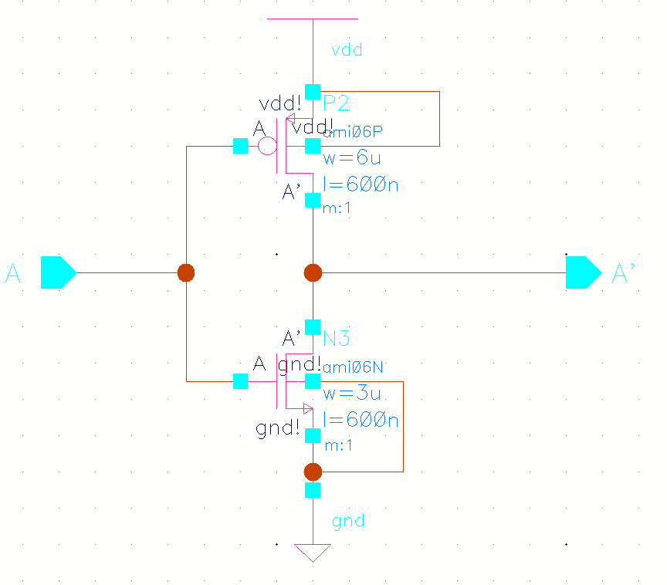

12/6 Inverter

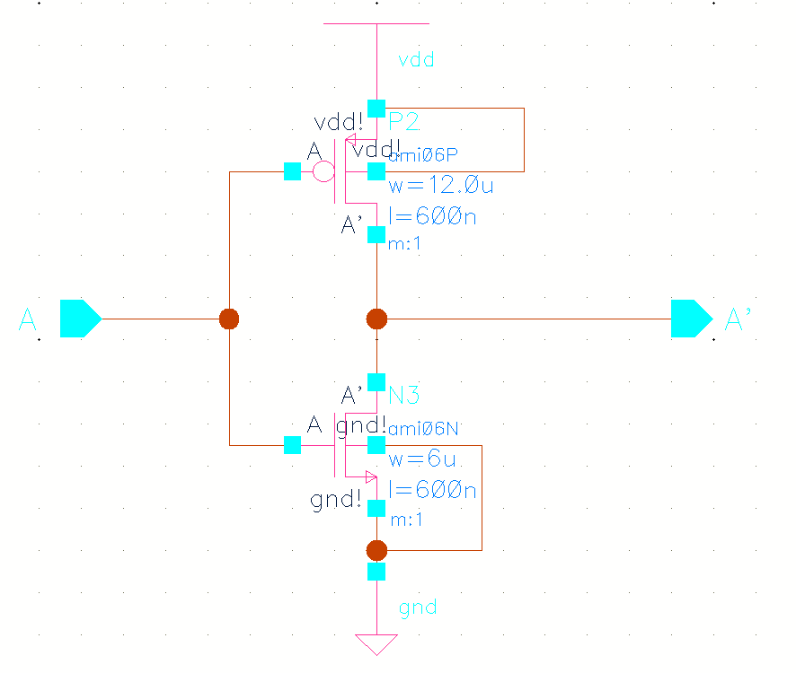

AND2 Gate

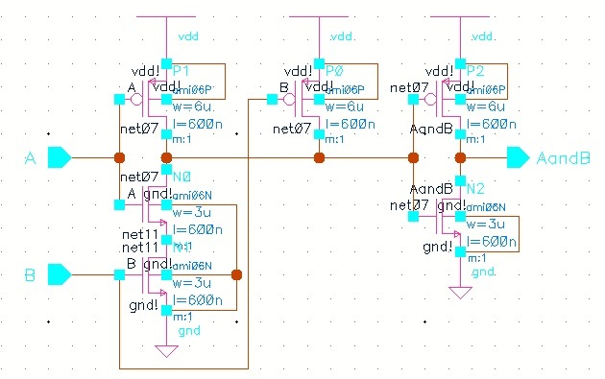

AND3 Gate

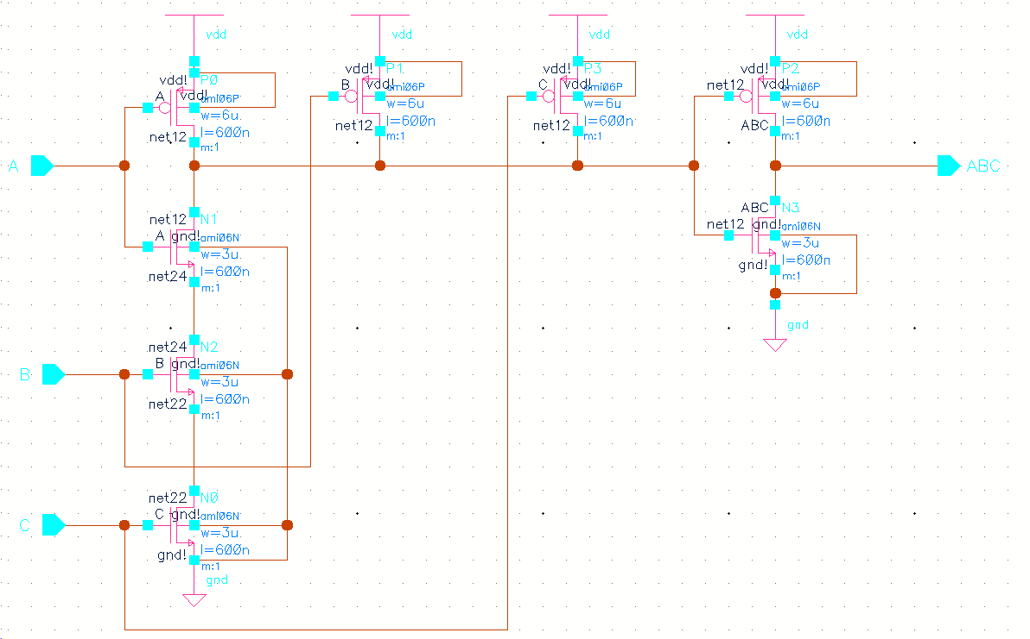

NAND2 Gate

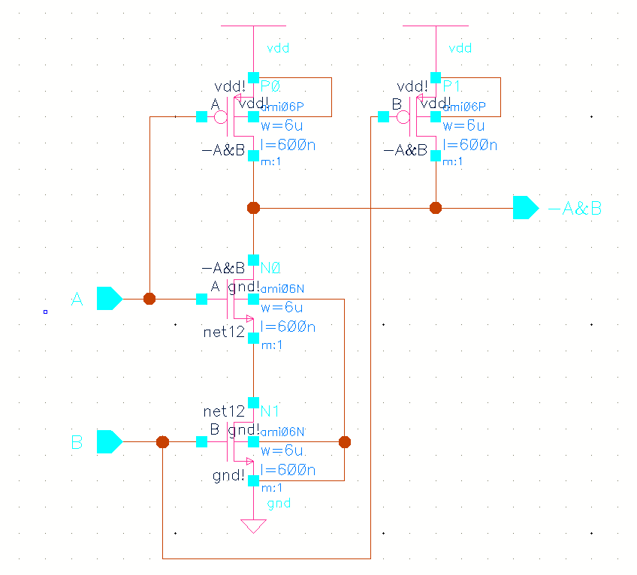

NAND3 Gate

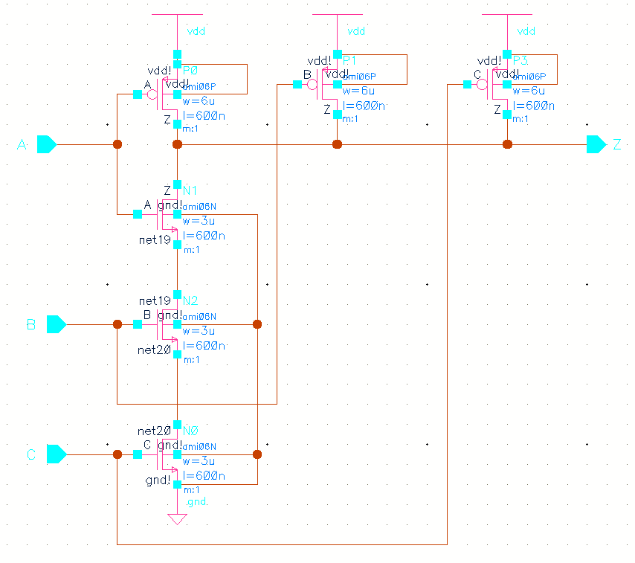

NOR2 Gate

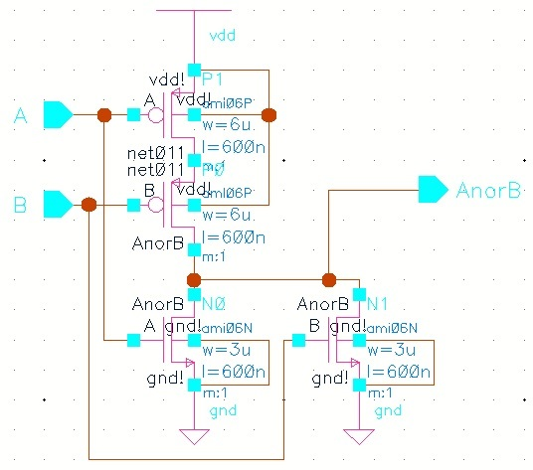

NOR3 Gate

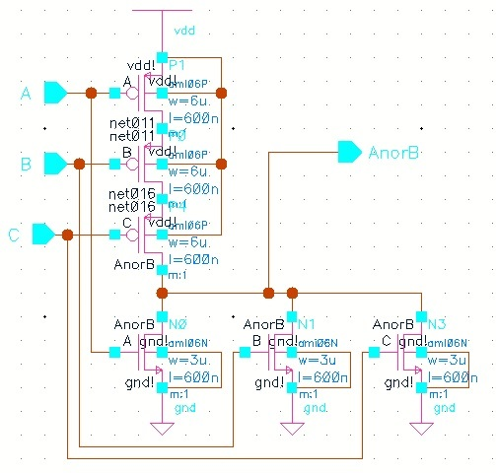

OR2 Gate

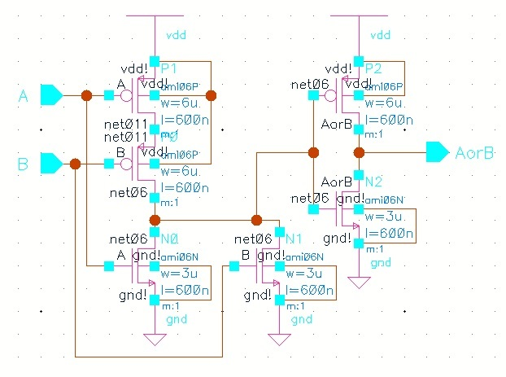

Tri-state Buffer

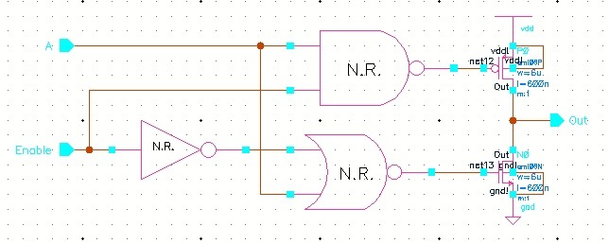

Alternate Tri-state buffer (used in other parts of design)

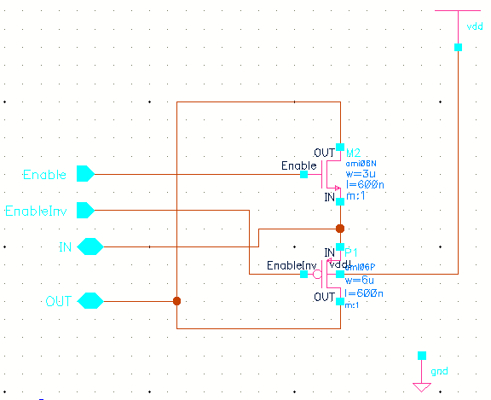

D-Flip Flop schematic (used in all of our registers; A very important circuit)

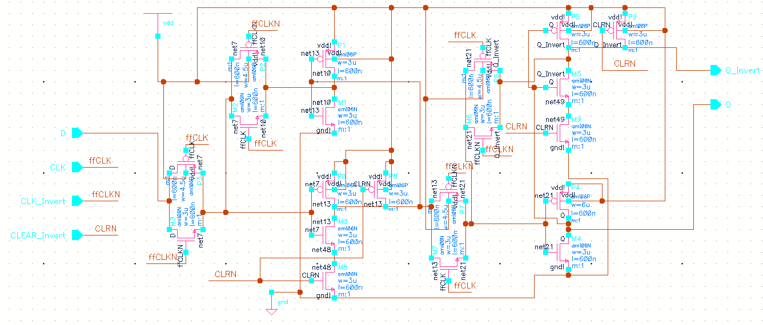

D-FF layout (because it is so important, we include the layout for informative purposes

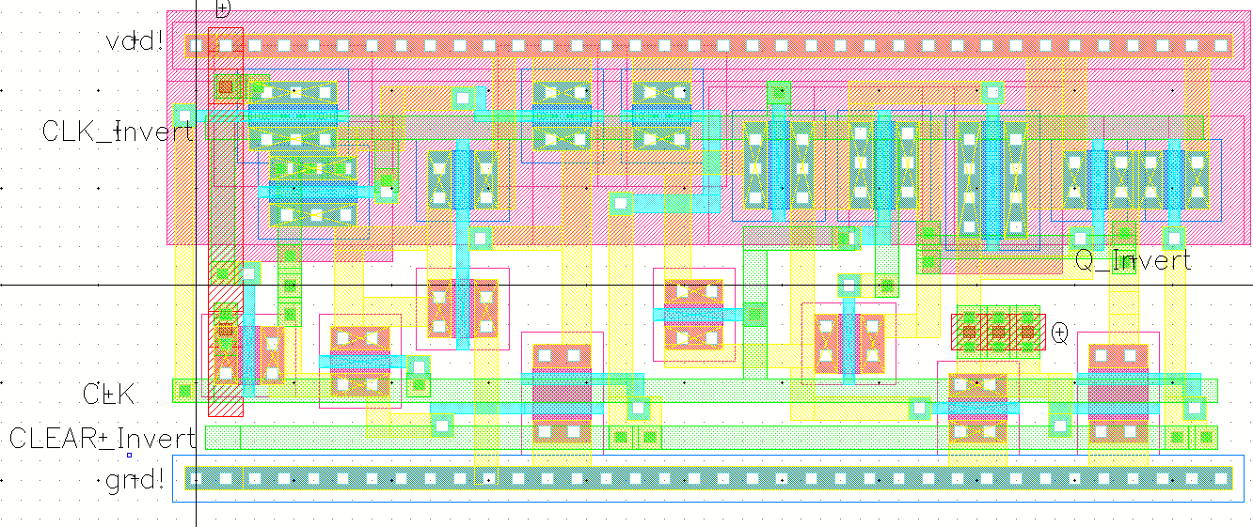

Bitline Isolator (TG plus logic)

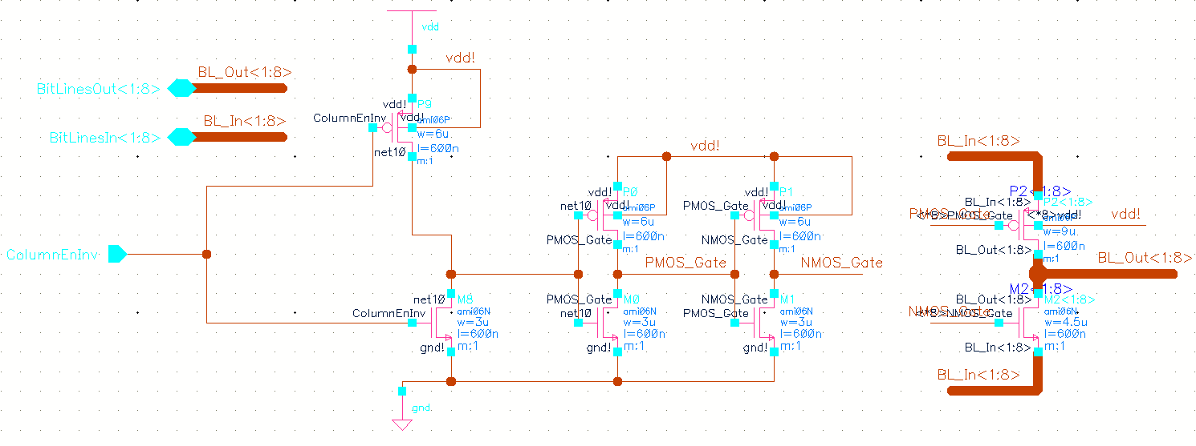

Upcounter Logic

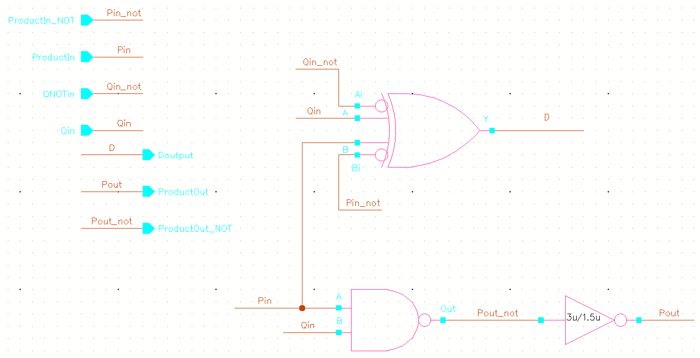

XOR2 Gate

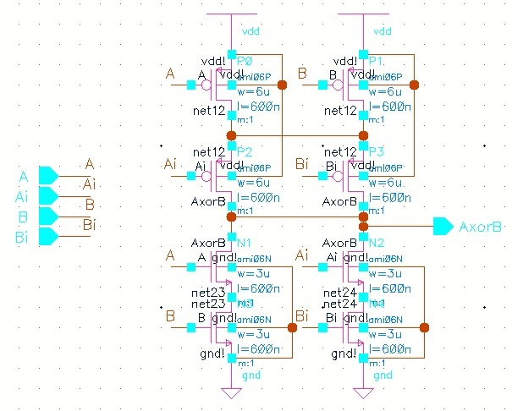

3-bit Upcounter (step counter)

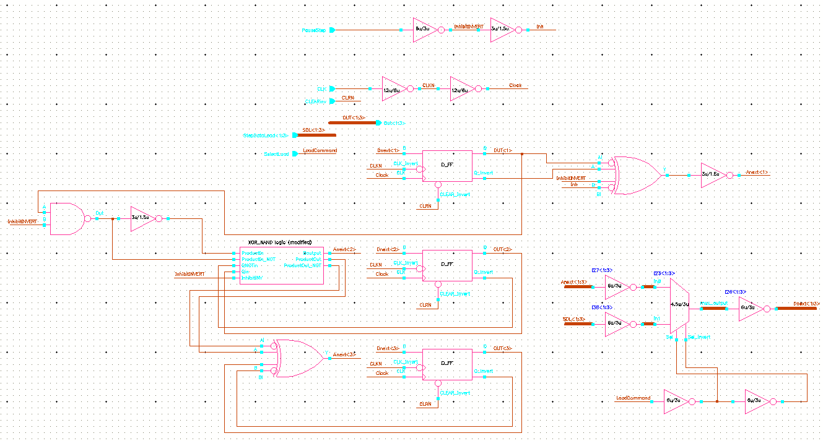

SRAM 64 byte array and support circuits

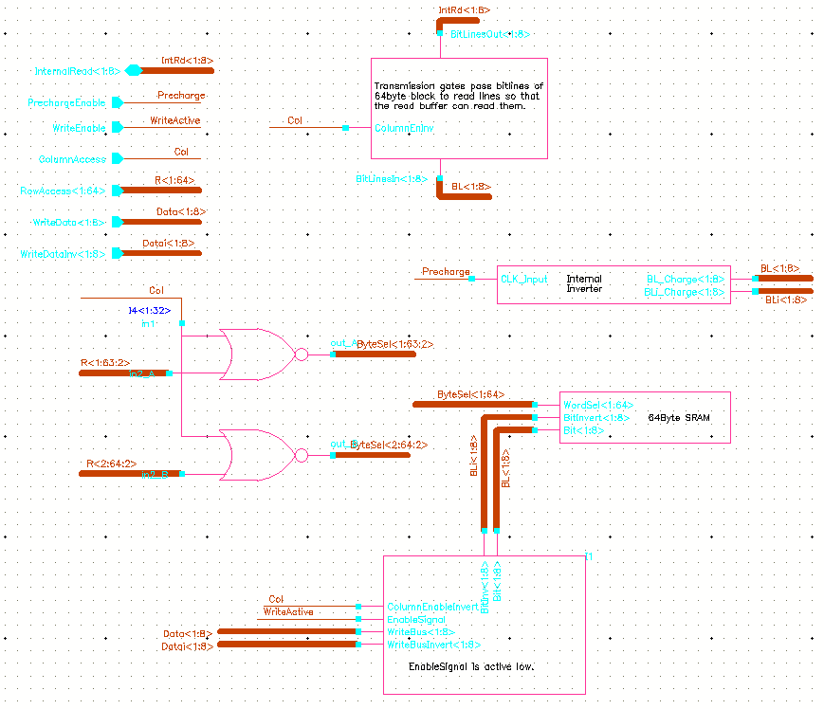

SRAM top-level schematic (first four arrays are displayed, missing write logic)

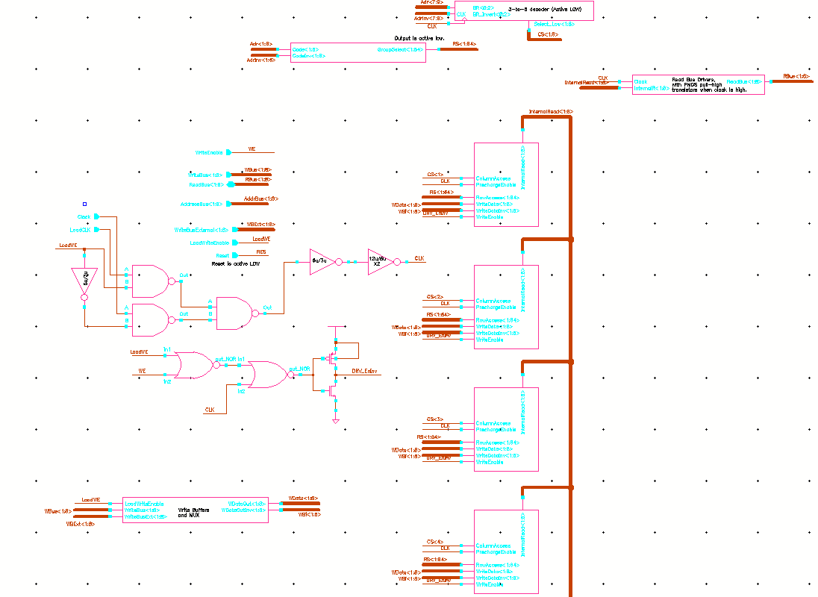

IR top-level, part 1

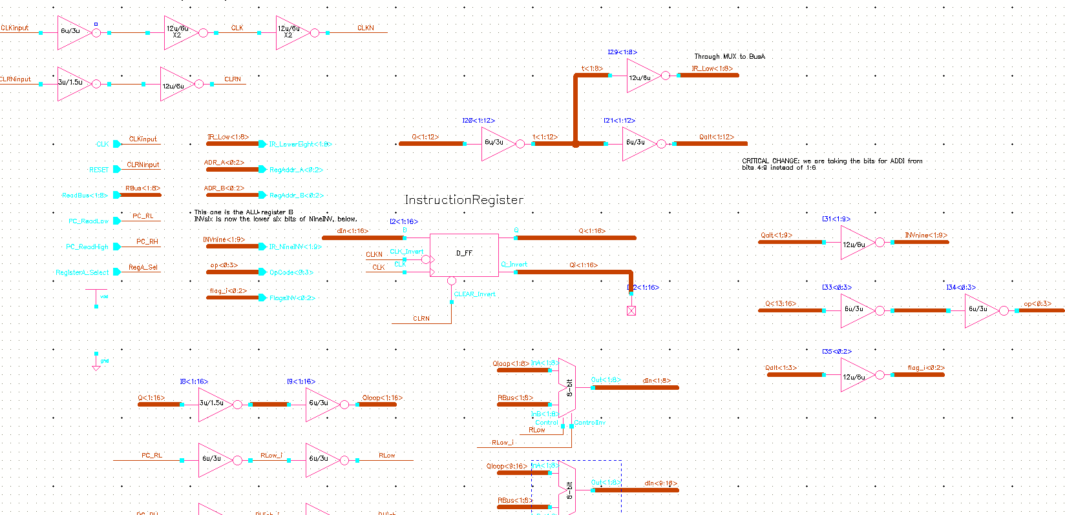

IR top-level, part 2

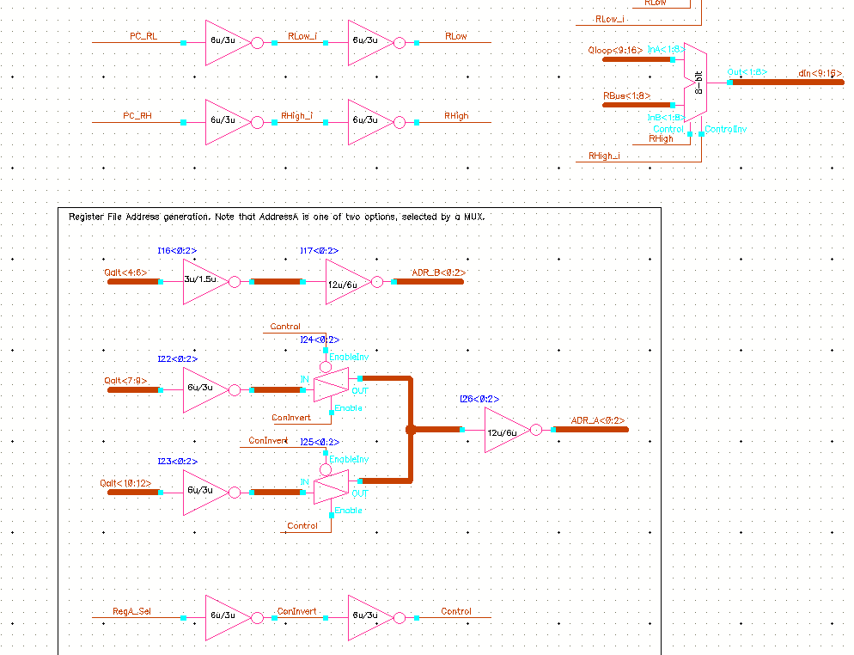

**A.2 Control Signal Generation For All Instructions**

This is an internal working document used to describe the exact control signals required at each step of an instruction. Note that the first two steps (step0 and step1) are always used to fetch the low and high bytes of the instruction.

This document will list the outputs asserted by the control unit for each instruction cycle. The fetch cycle is listed first, and is assumed for all instructions. The Step counter value is listed on the left as three binary digits.

Special signals not listed in Datapath_Comments are Step_Reset, which resets the control unit’s step counter, and Step_Pause, which will prevent the step counter from automatically incrementing (used for multi-step instructions like the shifting instructions).

Two additional control signals need to be added to the datapath. The Input_BusA and Output_BusA signals will read and write data from external ports to bus A.

**Note about comparison instructions**

These instructions use the “Register Instruction Format” with one register operand and a 9-bit immediate constant. The operand register is compared to zero and if the condition is true, jumps to the memory location indicated by the immediate value.

[Alternative design: compare registerA with literal zero, which will eliminate the extra control line and simplify these instruction]

USE THIS DESIGN!!

IS_GREATER is the contents of RegA (inside ALU) are greater than zero (signed).

IS_ZERO is asserted when the contents of RetB are zero.

Note for shift and rotate instructions: there is a 3-bit down counter within the ALU that is loaded with ALU_LoadCounter from the lower 3 bits of opcode. When this reaches zero it sends signal COUNTER_ZERO.

RF_WriteImmediate is another new control signal that directs the RF to load from the lower 8 bits of the IR instead of from BusA.

IMPORTANT:

The RF_WriteImmediate signal activates a TG that puts the signal on the BusA.

This is a very important point!!

//END IMPORTANT

**Fetch Cycle**

Step Ctr. Signals asserted for each step

000 - PC_Update, PC_ReadLow ;We do not need ReadMem_Enable, because we use separate enable logic to load the PC

001 - PC_Update, PC_RealHigh ; Load second byte into IR.

**ADDI**

010 - ALU_LoadA, ALU_LoadBImmediate, RF_ReadEnable

011 - ALU_Control[1] ; Add code sent to ALU

100 - ALU_Output, RF_WriteEnable, RegisterA_Select, Step_Reset

**ADD**

010 - ALU_LoadA, RF_ReadEnable ;not loading immediate this time

011 - ALU_Control[1]

100 - ALU_Output, RF_WriteEnable, RegisterA_Select, Step_Reset

**SUB**

010 - ALU_LoadA, RF_ReadEnable

011 - ALU_Control[1], ALU_Control[0]

100 - ALU_Output, RF_WriteEnable, RegisterA_Select, Step_Reset

**AND**

010 - ALU_LoadA, RF_ReadEnable

011 - ALU_Control[2]

100 - ALU_Output, RF_WriteEnable, RegisterA_Select, Step_Reset

**OR**

010 - ALU_LoadA, RF_ReadEnable

011 - ALU_Control[2], ALU_Control[0]

100 - ALU_Output, RF_WriteEnable, RegisterA_Select, Step_Reset

**NOT**

010 - ALU_LoadA, RF_ReadEnable

011 - ALU_Control[0]

100 - ALU_Output, RF_WriteEnable, RegisterA_Select, Step_Reset

**XOR**

010 - ALU_LoadA, RF_ReadEnable

011 - ALU_Control[2], ALU_Control[1]

100 - ALU_Output, RF_WriteEnable, RegisterA_Select, Step_Reset

**IN**

010 - RF_WriteEnable, Input_BusA, Step_Reset, RegisterA_Select [Why? Because for convenience, the output of the arithmetic instructions is to the first register….

**OUT**

010 - RF_ReadEnable, Output_BusA, Step_Reset, RegisterA_Select[?] ;Same goes for OUT command.

**JE**

010 - RF_ReadEnable, ALU_LoadA, RegisterA_Select

011 - (if !IS_ZERO) Step_Reset ;if regA is NOT zero, we stop

011 - (if IS_ZERO) PC_Update, PC_LoadImmediate, Step_Reset

;if we are at zero, load IR

**JG**

010 - RF_ReadEnable, RegisterA_Select, ALU_LoadA

011 - (if !IS_GREATER) Step_Reset

011 - (if IS_GREATER) PC_Update, PC_LoadImmediate, Step_Reset

; Jump to new location

**JGE**

010 - RF_ReadEnable, ALU_LoadA, RegisterA_Select

011 - (if !IS_GREATER && !IS_ZERO) Step_Reset

011 - (if IS_GREATER || IS_ZERO) PC_Update, PC_LoadImmediate, Step_Reset

**JNE**

010 - RF_ReadEnable, ALU_LoadA, RegisterA_Select

011 - (if IS_ZERO) Step_Reset

011 - (if !IS_ZERO) PC_Update, PC_LoadImmediate, Step_Reset

**LOAD**

010 - AddrSelect[address from IR], ReadMem_Enable, RegisterA_Select, RF_WriteEnable, Step_Reset

**NOP**

010 - Step_Reset [?] ;possibly move to step 4 (100) for greater delay?

**ROR**

010 - ALU_LoadA, RF_ReadEnable, ALU_LoadCounter

011 - if (!COUNTER_ZERO) ALU_Shift[0], ALU_Shift[1], PauseStep

011 - if (COUNTER_ZERO) ALU_Output, RF_WriteEnable, RegisterA_Select, Step_Reset

**SET**

010 - RF_WriteImmediate,RegisterA_Select, Step_Reset, RF_WriteEnable

**SHL**

010 - ALU_LoadA, RF_ReadEnable, ALU_LoadCounter

011 - if (!COUNTER_ZERO) ALU_Shift[0], PauseStep

011 - if (COUNTER_ZERO) ALU_Output, RF_WriteEnable, RegisterA_Select, Step_Reset

**SHR**

010 - ALU_LoadA, RF_ReadEnable, ALU_LoadCounter

011 - if (!COUNTER_ZERO) ALU_Shift[1], PauseStep

011 - if (COUNTER_ZERO) ALU_Output, RF_WriteEnable, RegisterA_Select, Step_Reset

**STOP**

010 - GateClock

**STORE**

010 - WriteMem_Enable, AddrSelect, RF_ReadEnable, Step_Reset, RegisterA_Select

**Simulation example of entire chip**

The following simulation runs the following code:

0x00 IN R5

0x02 SET R6, 0xf3

0x04 NOT R2, R6

0x06 XOR R3, R2, R5

0x08 JG R3, 0x0C ; *

0x0A OUT R3

0x0C STOP

*This jump starts executing at 3.4us, and jumps to the stop instruction, which loads opcode at 2.9us, causing the control unit to generate the GateClock signal.

